A Matter of Succession

D&D training oneshot created by Nick Pierson

Story Overview
How to Win
Characters
THE FAMILY
Orianna Humphrey (The late Countess)
Martin Humphrey (The Countess’ Brother)
Rosalia Humphrey (The Countess’ Daughter)
Aiden Humphrey (The Countess’ Son)
Jaina Humphrey (The Countess’ niece; Martin’s daughter)
Jacob Humphrey (The Countess’ grandson; Rosalia’s son)
OTHER NPCS
Frederika Townsend (Guard Captain)
Didier Lemieux (Butler, pronounced dee-dee-yay le-mew)
Rallum Oakpole (Chef)
Highstone Town Council
Encounters
Meeting the Family
Martin’s Encounter: Bottled Memories
Rosalia’s Encounter: Day in the Life
Aiden’s Encounter: I Don’t Mean to Bother
Jacob’s Encounter: Combat Chess
Jaina’s Encounter: The Secret Labyrinth
Room 1: Sphinx
Room 2: Animated Flying Swords
Room 3: Mud Mephits
Room 4: Enclosing Walls
Room 5: Quicksand
Room 6: Nothing!
Room 7: Instruments + Sphinx
Finishing the Story
Maps

Story Overview

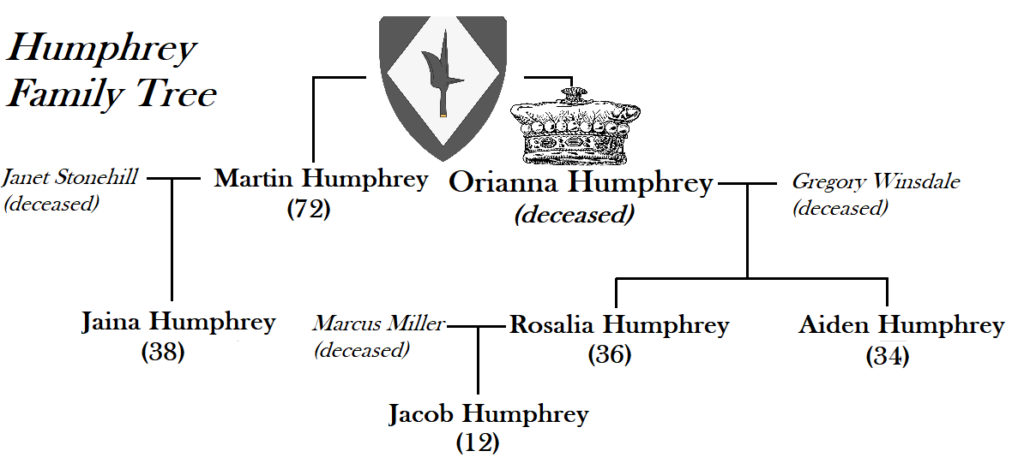

The human countess Orianna Humphrey, well beloved by her family and subjects alike in the town of Highstone, passed away peacefully in her sleep last week at the ripe old age of 73. After the funeral rites and celebration of life, her family sat down to read the will - only to find that she left them a blank page, naming no direct heir! The family has five potential candidates to succeed as count or countess:

-Martin Humphrey, her brother
-Rosalia Humphrey, her eldest child and only daughter
-Aiden Humphrey, her youngest child and only son
-Jaina Humphrey, her niece (Martin’s daughter)
-Jacob Humphrey, her grandson (Rosalia’s son)

For the most part, the Humphrey family get along quite well - perhaps too well, as four out of five have thus far refused to put themselves forward as a potential candidate. Only Martin has directly expressed desire to become the next count, but his daughter, niece, and nephew are hesitant to hand over the reins of power without fully understanding the late countess’ wishes.

The story begins with Frederika Townsend, captain of house Humphrey’s guard, seeking out our adventuring party as a group of neutral arbiters. For the purposes of this one-shot, we will assume that the party has recently made a name for themselves doing various good deeds in the region. The family tasked guard captain Frederika with seeking out an impartial group of good repute to assist in this matter of succession!

How to Win

Our party’s goal is to resolve the succession of House Humphrey - but there is no single correct answer for how to do so. They might decide to install the eldest child, Rosalia; they might go with the late countess’ brother, Martin; they might set up the young grandchild, Jacob, with a regency assisted by his family; they might cast aside noble succession entirely and create a town council, advised and assisted by the family!

Countess Orianna’s will merely looks like a blank page. The family has been distraught with mourning, stress, and uncertainty, so none have attempted to use magic on the will - if they used something like Detect Magic or a similar spell, they would notice hidden script revealing a single unfinished sentence:

“I leave House Humphrey in the care of someone who is” …

The remainder of the page will only reveal itself after the party interacts with each of the five potential heirs, resolving their mini-storylines to uncover a core characteristic that Orianna respected about them. Ultimately, the countess wanted her family to recognize one another’s strengths and support whoever they choose to lead the realm after her passing.

Martin (brother) adds to the will: “Discerning in judgment”

Rosalia (daughter) reveals: “Kind to one and all”

Jacob (grandson) reveals: “Quick-witted in strategy”

Aiden (son) reveals: “Curious and creative”

Jaina (niece) reveals: “Brave of heart”

Characters

THE FAMILY

Orianna Humphrey (The late Countess)

Orianna is not an NPC in the story as she has passed away, but her character looms large over the family and the realm. She was known as an intelligent governor, a valiant paladin, an honest administrator of justice, an affectionate mother, and a benevolent liege. If the party digs a bit deeper, they can uncover nuances and imperfections in her character. Her brother Martin admired and respected her, but deep down felt some jealousy towards her. Her daughter Rosalia and her son Martin loved her dearly, but dealt with pangs of absence as Orianna’s role as countess took her on travels far and wide throughout the realm, often leaving the children in care of the household staff (their father having met an untimely end in war). Her niece Jaina truly lionized her and strove to be the most like her, striking out as an adventurer. Finally her grandson Jacob ended up somewhat spoiled from her doting ministrations.

Martin Humphrey (The Countess’ Brother)

Background
Though he now stoops below average height and sports pure-white hair, Martin was clearly once a powerfully built warrior. As a young man Martin fought alongside his sister on behalf of the realm, fending off roving monsters and bringing highway robbers to justice. He also served as a trusted member of her administrative council and inner circle. Though he did not always show it, Martin held a deep affection for Orianna. Unfortunately Martin’s wife passed away three years ago of old age, leaving him distraught and somewhat cantankerous; with Orianna’s passing he grows increasingly adrift.

Roleplaying as Martin

On the surface, Martin presents as a classic ‘grumpy old man,’ often making comments such as “Back in my day, we did things the right way…” or “Children these days have no idea how good they have it. Why, we used to trudge out in the snow, walking miles uphill to track down dire wolves threatening the town…” or “I just do not understand how you young people can be so carefree.” With his two anchors - his wife and sister - both peacefully passed on, he does not always possess the emotional intelligence to check his irritability.
Going deeper, however, Martin still has a profound love for all his family members, especially his daughter Jaina - even as he is particularly stern with her, still trying to parent her to the best of his ability (while she increasingly needs to parent HIM!). He feels lonely as the last surviving member of his generation, and worried about how the younger generations will fare as they must shoulder the burdens of leadership.
Martin should be inclined to be gruff towards the player-characters in the party at first, questioning the need for their presence; he may “test” them in various ways such as trying to probe their intellect or their martial abilities. If the party takes the time to listen to him, however, they may be rewarded with his grudging approval. Martin responds well to being honestly, but not insultingly, called out on his antisocial behavior; he also responds well to the party being patient and simply tolerating his behavior until he becomes ashamed of himself enough to apologize and open up.

Rosalia Humphrey (The Countess’ Daughter)

Background

Rosalia is a woman of above average height, with long hair reaching halfway down her back, soft brown eyes, and a warm smile. She is the archetypal eldest daughter: intelligent, competent, kind, and probably doing much more at any given time than anyone is aware of. From a very young age, she took an active hand assisting her mother in governing the realm. While Orianna often ventured to nearby realms to conduct diplomacy with other minor nobles, or led her soldiers-at-arms alongside the town watch to defend the realm against threats, Rosalia solved problems and accomplished key tasks with a tireless work ethic. As young as 12 years old she could be seen helping the countess’ financial minister with accounting, resolving minor disputes between farmers or craftspeople, and helping with planting or the harvest. She only took on more responsibilities as she grew into adulthood, watching over her younger brother as much as her parents did.
Rosalia married a commoner, Marcus Miller, and had a son at age 24. Marcus sadly passed away not long after in one of the realm’s defensive battles against an incursion of displaced bandits from a neighboring county. This tragedy led Rosalia to investigate the root causes of banditry, pledging herself to bettering the conditions of everyone in the county so that no one would have to resort to violence to feed their families. She has not yet remarried, instead devoting herself to her work as well as raising her son (who she can’t help but spoil sometimes).

Roleplaying as Rosalia

Rosalia is doubtless the most qualified person to be the next countess. However, she wants it the LEAST - even though she might not express that directly. Rosalia is known to say things like “I’m just honored to play whatever role we need most,” or “Even if we are not able to figure out Mother’s exact last wishes, I am certain we can come to a consensus.” In a way Rosalia has been trapped by her own competence; with her mother’s passing of old age, she is hoping for a reset of sorts where she might be free to pursue her own life. She is not even sure herself of what that might look like - traveling the seas? Building her own farm? Taking on a more modest role on the town council? She loves her family, especially her son Jacob, and wants to keep his wishes in mind as well. But Rosalia has a spark of adventure that she has never been able to pursue. As DM, you can decide whether she might be persuaded that being countess could be her next adventure- or whether she would rather wash her hands of the whole thing.

Aiden Humphrey (The Countess’ Son)

Background

Aiden stands around average height, with a shock of messy hair, worried brown eyes, and an expression of perpetual panic. Aiden wants desperately to be of use - and he is, at the best of times. Unfortunately, he is also prone to anxiety spirals as he compares himself to his mother and sister. Neither the martial nor the administrative aspects of governing a realm came naturally to Aiden. As a child, he gravitated more towards capturing quiet moments - painting a watermill, fishing by the lake, listening to birdsong in the forest. His parents and older sister created an environment where he could do all these things safely and peacefully.
As Aiden grew older, however, he felt increasing pressure to contribute as a member of a noble family. This pressure stemmed almost entirely from external forces. Aiden’s parents and sister only ever encouraged his artistic and natural pursuits; however, in socializing more with other noble children at feasts, tourneys, and other events, poor Aiden became the target of bullying. As a result he tried to force himself into becoming “more noble-like.” Unsure of this change, but desiring to respect his resolve, Rosalia in particular helped Aiden down this path - tutoring him in reading, history, horseback riding, swordplay, and more. He earned a place for himself as Rosalia’s unofficial assistant, administrating the realm in the frequent cases where his mother was traveling elsewhere.

Roleplaying as Aiden

Aiden often drives himself to an anxious state stressing out over how he could do better. He is more competent than he gives himself credit for - but he always falls back to comparing himself unfavorably to his sister and mother. He’ll say things such as, “I’d love to help you out - um, my apologies, Rosalia is busy at the moment, but I will do the best I can - that is to say, the best I’m able. Sorry!” or “Perhaps we should simply re-read mother’s letters - I’m certain there are more clues in there!” (spoiler alert: there are not)
Aiden also wants nothing more than to spend quiet afternoons creating art, playing with his nephew, or just spending time in nature. He has suppressed these tendencies for years due to bullying by his peers - at this point, he does not even seem to recognize that he is a full grown adult capable of pursuing his passions without needing fear judgment.

Jaina Humphrey (The Countess’ niece; Martin’s daughter)

Background

Jaina is a powerfully muscled woman with short-cropped hair, a long scar running across her right cheek, and an almost pathological need to always be in motion. Out of all of Oriana's family and descendants, Jaina most resembles the late countess in temperament and lifestyle. Like her aunt, Jaina took the oath of devotion in her studies as a Paladin. In her mid twenties Jaina set off as an adventurer, roaming far and wide to help those in need. Though her travels kept her away from Highstone Manor for much of her adulthood, Jaina always made a point of returning home at least once each year for an extended period of quality time with family.
Jaina was the last of the Humphrey family to return for the funeral rites, returning from another adventure after receiving a letter from house messengers.

Roleplaying as Jaina

Jaina possesses courage and wit and equal measure. She can be a bit headstrong, taking after her parents- sometimes she prefers to get to the point rather than mince words. As a veteran adventurer, she will respect the party by default and probably wish to help them along their way. Keeping her cantankerous father in good behavior occupies much of her time and energy. She’s known to say things such as “Apologies for my noble father’s ill humor,” or “I think we should tackle the matter head-on!” or just “Dad! Stop it!” She does get along well with her cousins Rosalia and Aiden, as well as her ‘nephew’ Jacob (technically first cousin once removed, but nephew is easier).
As for her motivations, as DM you can decide whether she would be eager to take up the mantle of Countess, or whether she still yearns for the open road with her adventuring party (of course her party could be made advisors or part of the town watch if she did take over).

Jacob Humphrey (The Countess’ grandson; Rosalia’s son)

Background

Jacob is a bit small for his age, though his growth spurt looks to be right around the corner. He is a bright, curious child who has grown a biiiit spoiled thanks to his doting mother and late grandmother. Jacob always had a special bond with his grandma Orianna, learning to play Dragonchess with her alongside other noble pursuits such as calligraphy and archery. He attends an academy for children of both noble and common birth, where he made many friends with his energetic demeanor. It’s not entirely clear how many of those friends are genuine, versus simply wanting to be in the orbit of a noble family.
While Jacob shows promising strategic and tactical aptitude, he still needs to learn patience in matters of governance and administration. He prefers martial training or imaginary war-play with friends to quiet contemplation and book learning.

Roleplaying as Jacob

Jacob is not a BAD kid. Think of him as a friendly, mostly fun little ball of energy who just hasn’t been told “no” enough in life. 12 years old is old enough to be surprisingly smart in some areas - and young enough to be shockingly ignorant in others. Jacob has aged out of the younger kid habit of constantly asking “why? Why? Why?” but is still young enough to pepper adults with questions. He may say things to the party like, “Want to play Dragonchess with me? I’m pretty good…” or “Are you real adventurers? What’s the biggest monster you’ve fought?” or “Have you read ‘The Beholder’s Glare?’ My tutor got it for me and I just read it five times!”
As a spoiled-but-fundamentally-decent rich kid, Jacob will try to befriend the party and even monopolize their time with his games and questions. He may react with surprise or dismay if they rebuff his attempts to make them play with him- here, gentle parenting will go a long way.

OTHER NPCS

Frederika Townsend (Guard Captain)

An Orc Fighter, captain of the Highstone guard. She is professional, capable, friendly, and determined to see this succession resolved peacefully. Frederika will gladly answer base-level questions about the family if the party asks (none of the deeper characteristics should be revealed, but she can give the party some basic info). She will not go along with the party to help in any of the encounters, as she has her own duties to attend to.

Didier Lemieux (Butler, pronounced dee-dee-yay le-mew)

A Tiefling commoner, butler of House Highstone. The Humphreys run a house with minimal staff: the late countess Orianna always believed in doing things oneself, and passed this value down to her descendants. Didier serves as butler, sommelier, and general assistant. Calm, cool, collected- Didier oozes grace and possesses an almost undetectable sense of humor. Like Frederika, Didier will answer any basic questions politely, but will not go past surface level (at first).

Rallum Oakpole (Chef)

A Dwarven commoner, head chef of House Highstone. Rallum prides herself in being able to prepare any kind of food, from the most gourmet multi-course meal to the simplest, most humble stew. She is endlessly cheerful, but will avoid answering questions about the family, saying that’s “not her business.” She does like to sneak treats to young Jacob.

Highstone Town Council

A group of town-voted councillors who handle administrative matters alongside the Humphrey family. In order to reduce mental load in roleplaying too many NPCs, you may choose to treat them as a single unit that is generally favorable to the Humphrey family, but somewhat worried about a chaotic succession. If you wish to expand further on this group (or it seems like the players want to explore this thread more), you can give them all unique personalities, or simply adopt the following approach splitting the council between pro-nobility and pro-democracy factions (pro-democracy meaning greater independence for the town):

Alan Miller - Human, pro-nobility
Veska Cragspring - Tiefling, pro-nobility
Lily Holden - Half-elf, pro-democracy
Anastasia Belinka - Halfling, pro-democracy
Grimbold Windchaser - Orc, undecided

Character RP Cheat Sheets

Martin  -Grumpy (think Carl from Up)  -Lonely; worried  -Secretly proud of family | Rosalia  -Takes care of everything (think Luisa from Encanto)  -Wise  -Compassionate
Aiden  -Second-guesses himself (think Chidi from The Good Place)  -Unsure who he wants to be  -Eager to please | Jacob  -Energetic (think Nemo from Finding Nemo)  -Intelligent  -Slightly spoiled/naive
Jaina  -Valiant knight (think Brienne of Tarth from Game of Thrones, but more confident)  -Friendly  -Can be hasty | Other characters  -Frederika: stoic guard captain (think Pieck from Attack on Titan)  -Didier: suave butler (could be played like Sebastian from Black Butler)  -Rallum: chef (potentially Sydney from The Bear)  -Town council (wise, incompetent, or anything in between per DM discretion)

Encounters

Meeting the Family

The adventure begins with guard captain Frederika Townsend finding the party, asking for their help in resolving the matter of succession, and escorting them to Highstone Manor. If the party wants, they can ask Frederika questions on the road to the manor, or you can simply skip to their arrival. The party arrives in the evening and will meet butler Didier Lemieux at the entrance. Didier informs the party they’ve been invited to dinner as a thank you for accepting this job.
At the dinner table, the party gets their first impression of the whole family. Space them out at the table to leave room for the party to intermingle. Here you could briefly role-play some interactions between the five - perhaps Rosalia welcoming them in, Aiden echoing her and anxiously asking if they need anything, Martin saying something grumpy, Jaina telling her dad to be nice, and Jacob excitedly asking them about their travels. Rosalia hands the party the blank will to inspect. Then give the party a chance to have an initial interaction with the family. This can either be done all together, or in separate 1-on-1s as the party splits up around the table to talk to different family members.
Here - or anytime in the adventure - the party can reveal the first line of the will (see the How to Win section) in a variety of ways:
-Using Detect Magic, which reveals that enchantment magic was used AND simultaneously reveals the first line
-Passing a DC 10 Arcana check, which allows the party to sense the magical energy Orianna imparted unto the will, and coax out the first line
-Exposing the will to moonlight
-Attempting to write anywhere on the page

During their conversations at dinnertime, the party is likely to ask the family if they have any clues about what Orianna wished for her succession. All express uncertainty, but Rosalia or Aiden will both mention that over the last year before she passed away, Orianna got everyone in the family very specific gifts - unusual for her, since usually she simply gave money for birthdays.

-Martin received three casks of fine wine from far-off realms
-Rosalia received a huge, gold-embossed ledger and a lifetime supply of quills and ink
-Aiden received a masterfully crafted fishing pole and a variety of magical lures
-Jaina received a masterwork warhammer and a generous supply of weapon + armor oil
-Jacob received a new Dragonchess set

Each of these gifts is associated with an encounter involving that member of the Humphrey family! The party can choose to begin pursuing any of these threads the very first night they arrive, or they can choose to return to their quarters and long rest before starting the next day. Two of the five encounters explicitly include combat (Jaina and Jacob), two are purely roleplay (Rosalia and Martin), and one includes optional combat (Aiden).

Martin’s Encounter: Bottled Memories

If the party asks about Martin’s gift of foreign wine-casks, he will proudly say that he hasn’t touched any of them all year long - then invite the party to partake in some of his other wine stores. (For characters and/or players who prefer to abstain from alcohol even in a roleplay context, he also has sparkling grape juice). On any day after dinnertime (including the first day), the party can choose to take Martin up on his offer.
To resolve Martin’s encounter, the party simply needs to get him to break open one of the prized foreign wine-casks he got as a gift from his sister, and share some with the party: doing so will reveal Martin’s line of the will. (Note: Martin must do this voluntarily, not have someone in the party just smash them open). However, he will not do so unless he warms up to the party.
Martin offers the party a series of wines (or NA grape juices for those who prefer) with accompanying skill checks. Any number of party members can drink or decline in any round. These skill checks do not necessarily impact the end goal, which is to win Martin’s trust, but can change the way the encounter plays out.

Wine 1: Red blend. DC 10 Constitution check to avoid getting mildly buzzed. Martin will be impressed with any PCs who can hold their drink, and amused by any who cannot. While sharing this wine, Martin will ask the party why they’re qualified to help out with the matter of succession. He is looking for honest answers.

Wine 2: Riesling (white wine). DC 15 Nature check can reveal the exact region in a forested hill north of Whitestone where the wine is from. Martin will be impressed with any players who discern this; however, even if no one passes, he will be equally pleased if anyone is curious enough to ask about its origins. While sharing this wine, Martin might tell a short story about “back in my day” when he and Orianna fought off a rabid owlbear to protect some woodcutters. He will exaggerate but the story is fundamentally true. Martin gains trust in the party if they respond positively to his story.

Wine 3: Rose (pink wine). This wine is actually laced with truth potion, acting as a mini- Zone of Truth spell on anyone who drinks it. DC 15 Charisma saving throw to avoid the spell. Players will be aware the spell was attempted, and Martin will say he’s looking for an honest answer: based on their impressions so far, who do they think will make the best candidate for new count or countess? As with the first wine, Martin is looking for honest answers - whether or not the players succeeded on their saving throw.

If Martin has positive interactions with the party for wines 1-3 OR if they have already completed two other family encounters, he will freely offer to share one of Orianna’s bottles, thus revealing his corresponding line in the will and concluding the encounter. If ⅔ wines went positively, he can be persuaded with a DC 10 Persuasion check to share; if only ⅓ went well, the DC will be 15. If no one in the party can pass the check, they will have to return to Martin after completing at least three other encounters, at which point they will have earned his trust.

Rosalia’s Encounter: Day in the Life

If the party asks Rosalia about her ledger, she tells them she uses it as a personal organizer and journal, and invites them to come along for a morning (or afternoon) with her if they’d like to know more. Rosalia’s de facto duties as administrator of the realm keep her incredibly busy; the party will have to tag along if they want to interact with her.
To resolve Rosalia’s encounter, the party needs to get her to write down something in her ledger about her OWN goals, her OWN plans, her OWN dreams; right now, the ledger is packed to the brim with everyone else’s business that she handles.
The most recent entry in her ledger starts with notes on Jacob’s itinerary for the day, which she writes each night before bed. Jacob is currently on leave from academy as it’s on break for summer, so she fills up his day with things like “Horseback lessons - Archery - History - Dragonchess lessons - Music” etc. Next she has notes on business in the town of Highstone: a supply requisition from a mining crew, a dispute between two villagers over a sickly goat, and a visit to the watermill to inspect a newly replaced millwheel. In town, Rosalia would like to end at the millwheel, but can take care of the other two tasks in any order and will ask the party which they’d prefer to do first.

Mining Supply Requisition

A mining crew contracted with the Humphrey family to mine iron ore in a nearby cavern system. However, the early stages of mineshaft expansion have gone worse than expected, leading them to request additional food and tool supplies. The crew has no more money to pay at the moment, and is hoping for credit.
Rosalia always aims to help, but she is also pragmatic. First she will ask the party what they would do in such a situation. She herself has two options in mind: either have the miners offer future ore to the town of Highstone at reduced rates, or have the miners promise to contract exclusively with Highstone for future mining projects. If the party offers a similar plan, she will go along with it; if not, she will offer the miners her two options, and they will accept one by default. (Note: this mini-encounter is designed more to showcase Rosalia’s character than anything else).

Sick Goat Dispute

A farmer sold the runt of the litter to another farmer at a modest discount, telling him “my ol girl has had runts twice before- one never made it to old age, the other became my best milking goat ever, so you never know!” A year later, the runt remains small and sickly, contributing little and requiring much care. The buyer feels misled and now demands half the price back, while the seller claims he was honest from the beginning. Before taking the matter to the town court, the farmers seek out Rosalia to act as an informal arbiter.
As with the mining situation, Rosalia will ask the party what they think. Her own inclination is to gently side with the seller - he did caution the buyer that the runt might be a dud, after all - while simultaneously appealing to the seller’s sense of fairness, asking whether there’s anything they could do to help out, and how would they feel if this happened to you? With the party’s persuasion and/or Rosalia’s plan, the seller can be convinced to offer the buyer their pick of healthy goats from the next litter at a bigger discount.

Optional - Town Council

If the party seems interested in upending the tradition of noble rule, you could add a piece here where they meet with the town council and discuss democratic alternatives.

Millwheel

Here Rosalia sees the fruits of her labor: she was the first to identify rotting wood in the old millwheel, and helped coordinate woodcutters, carpenters, and craftspeople in replacing it. It’s operating beautifully and she nods with satisfaction at a job well done. Rosalia will then write an account of everything that transpired today, and start writing about tomorrow. At some point she will muse aloud “I wonder what I’d do if I didn’t have all this to do.”
If the party pursues this thread, she will grudgingly start to talk about adventuring or sailing the seas or building her own farm (DM’s discretion - or anything else!). Once she writes ANYthing about her own dreams in the ledger, her line will reveal itself in the will. (If the party is not picking up on this angle, hint heavily that the ledger is almost begging to be written in - mention how it doesn’t have any of her own idea, just pages and pages of taking care of other people’s problems)

Aiden’s Encounter: I Don’t Mean to Bother

In the days since his mother’s death Aiden has been anxiously scurrying around the house, trying to figure out the secret of the blank will without any real idea of how to do so. He has re-read various letters Orianna sent during her travels (usually brief accounts of “We vanquished some bandits, hope everyone is well!” or “The diplomatic mission to our neighbor is going smoothly, hope to be home soon!” or “Be nice to your sister”, etc). He is trapped in a guilt spiral where he wants to go help Rosalia with town administration, but feels too distraught to do so; then the guilt compounds as he can’t bring himself to leave the house.
Meanwhile, the beautiful fishing rod gifted by his mother last year collects dust. To resolve Aiden’s encounter, the party needs to go fishing and recover a chest at the bottom of the nearby lake, guarded by a “lake shark” (we will ignore the practicality of this; it’s D&D!). If the party doesn’t explicitly go for a fishing trip based on the rod being Aiden’s distinguishing gift, then you as DM can nudge them with hints until they head to the lake. Though he feels guilty, Aiden can ultimately be persuaded with a persuasion DC as low as 5 if the party reminds him that his mother meant for him to use the gift, or as high as 15 if the party hasn’t engaged with him and just tries to drag him along.
The nearby lake features our lazy ‘lake shark’ which will use the stats of a Hunter Shark for the purposes of the encounter. It’s an elderly shark that somehow made its way here and decided to settle down in its old age. Sleeping most of the day and night, it occasionally hunts a fish or two before going back to its lair near a hidden treasure chest. Aiden has always been curious what the old shark is guarding, but he feels too nervous to disturb it and avoids that part of the lake as a result.
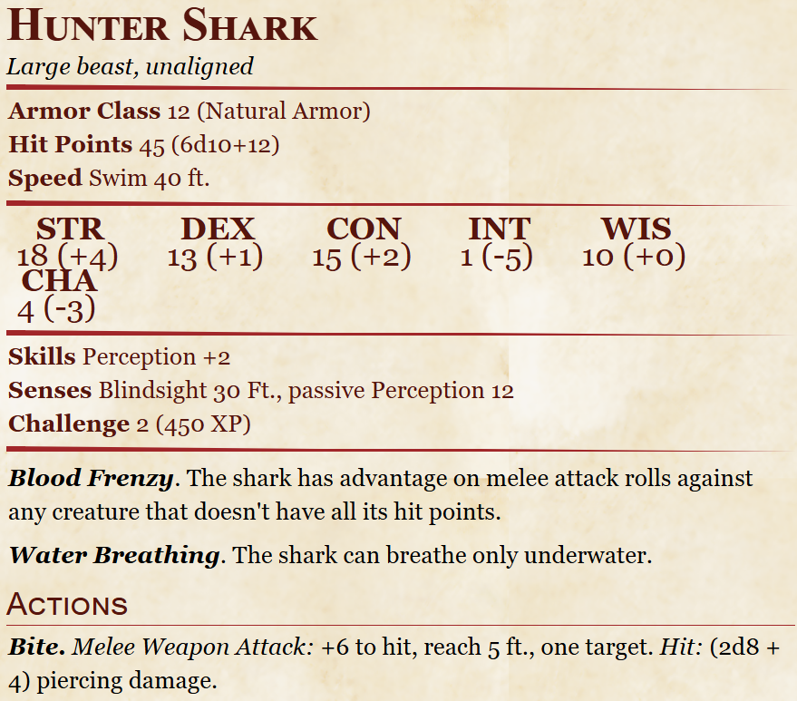
When the party arrives at the lake, they should make an initial skill check, choosing between Investigation and Perception (each player may choose a different check), with the following results:
10+ tells them it is a calm lake, fed by a river to the north that exits to the south, with a variety of mid-size fish and one large lake shark lurking at its deepest point
15+ gives everything from 10+, as well as that the shark appears to be circling on top of something hidden at the bottom of its lair
20+ reveals everything from 10+ and 15+, as well as a faint glint from what appears to be something metallic in the murky water below the shark

The party can choose to resolve this encounter through noncombat means, such as distracting the shark or befriending it using speak with animals/wildshape/etc, or combat with the shark. A Nature check of 10+ reveals that the shark appears quite lethargic; 15+ tells the party that it seems unlikely to attack unless severely provoked. If the party takes a distracting or diplomatic route, the shark can be lured away from its lair with illusions or actual tasty-looking fish, or the party can simply talk to it and find out that it has noticed Aiden (“that land-fish”) fishing and wonders why he never comes near the shark’s part of the lake. Further conversation with the shark will allow the party to persuade it to leave its treasure in exchange for fish (can be caught with DC 10 Survival, multiple attempts permitted) or a friendly swimming competition (the shark will always win unless the party uses some sort of magic shenanigans, but it will be sufficiently impressed with an Athletics check of 10+). If the party instead chooses to fight, it can be a somewhat tricky battle; Aiden will be too nervous to join but he will provide waterbreathing potions so that the party can at least fight without worrying about drowning.
Once the party has secured the chest at the lake bottom, they can either open it underwater (a difficult DC 20 Sleight of Hand check) or haul it up to land (DC 15 Athletics check, reduced by 5 for every additional party member helping) and open it there (a much easier DC 5 Sleight of Hand check to open the rusted clasp). The chest contains paintings Aiden made from childhood through young adulthood, kept by his mother as mementos of his artistic dreams. This will also reveal Aiden’s corresponding line in the will.

Jacob’s Encounter: Combat Chess

Young Jacob will likely pester the party with requests to play-fight with wooden swords, race him outside in the garden, and above all play Dragonchess. At some point, ensure that Jacob is able to talk to the party outside of earshot of the rest of his family - he will then excitedly tell them that his grandma got him a special Dragonchess set, and they should play with him when moonlight strikes the entrance hall tiles at night. He’ll have to sneak out of bed to do so, but it will be worth it, he assures the party!
When the party meets Jacob at night, he excitedly sets up his tiny Dragonchess pieces, each on their own floor tile. At first they look comically small, but once moonlight shines in through the window, one of the two Dragonchess sets suddenly grows to one-quarter of a human size proportions and sets up in formation opposite the party! Jacob expresses some confusion - normally both sets ‘come to life,’ he explains, and he gives them orders to fight one another for awhile before they shrink back to toy-size and become lifeless again. He wonders if maybe because the party is here, they’re meant to replace the other side’s pieces?
This combat encounter takes place in an 8x8 grid made up of tiles; once the party steps into the space opposite the lifelike pieces, they will shrink to one-quarter of their size temporarily. A few magical rules are in place:
-The party can freely move back and forth between the grid and outside the grid, where they will become normal sized again, but they cannot attack the enemy pieces while they are normal-sized
-The game ends once the opposing Lord has been felled
-The party should roll initiative once everyone is set up to their liking. Do not roll initiative for enemies. Instead, after each party member’s turn, one enemy piece may move.
-8 enemy pieces exist, with 4 types. See the table below for key stats

Piece | Movement | HP | AC | Attack | Special
Soldier (pawn) | 10 ft straight ahead (their first move); 5 ft straight ahead otherwise | 4 | 10 | Spear  +2 to hit  1d4 damage | CAN ONLY TARGET ONE SQUARE DIAGONAL IN FRONT OF THEM
Lancer (rook) | Unlimited; forward/backward or side/side only | 8 | 12 | Lance  +3 to hit  1d6+1 damage | CANNOT MOVE THROUGH FRIENDLY PIECES
Warrior Queen (queen) | Unlimited | 16 | 14 | Sword  +4 to hit  1d6+2 damage | CANNOT MOVE THROUGH FRIENDLY PIECES
Lord (King) | 1 square any direction | 16 | 8 | Mace  +2 to hit  1d6 damage | As a reaction, can transfer damage from a single attack from self to another piece within 5 feet

4 Soldiers, which behave like chess pawns (can only move 2 squares forward on their first move, then 1 square forward after; can only attack enemies sitting 1 square diagonally away)
2 Lancers, which behave like rooks (can move unlimited in a straight line or sideways to attack, but CANNOT move through their own pieces)
1 Lord, which can only move 1 square in any direction at any time, and CANNOT move through their own pieces
1 Warrior Queen, which can move unlimited in any direction (straight, sideways, diagonal) and attack, but CANNOT move through their own pieces

If the party has some baseline chess knowledge, the encounter may be somewhat easy; feel free to increase the opposing pieces’ base HP to compensate if you like. If the party does not, you can hint at the capabilities of each enemy piece by describing their frustration when they aren’t able to reach a party member, or their joy when they can make a successful attack. As a final optional rule, you could make it so that a Soldier that makes it all the way to the end row where the party starts can transform into a Warrior Queen.
Once the opposing king has been defeated (HP reduced to 0), Jacob will congratulate the party on doing the coolest thing he’s ever seen, and his corresponding line in the will is revealed.

Jaina’s Encounter: The Secret Labyrinth

Jaina is antsy to resolve the succession matter and get back to her adventures. Unsure of her own role to play, she tends to take books from the library and read them in the armory, occasionally circling the room to look at Orianna’s old weapons and suits of armor. In particular she seems fascinated by a central glass case containing Orianna’s plate armor. The case is unlocked, and can be opened freely; the family rarely do so out of respect.
To initiate Jaina’s encounter, the party needs to convince her to use her weapon OR armor oil (the gifts she received) on any item in the armory, or even on her own master-crafted warhammer. Doing so will cause the entire plate armor glass case to move backwards one tile, revealing a narrow spiral staircase leading deep below the manor. Following this staircase reveals an entire labyrinth that Orianna apparently constructed at some point unbeknownst to the rest of the family (Jaina will comment on how odd this is - and request to accompany the party).
The labyrinth contains the following challenges:

Room 1: Sphinx

Room 2: 3 animated flying swords
Room 3: 4 Mud Mephits
Room 4: Enclosing walls
Room 5: Quicksand
Room 6: Empty (red herring room!)

Room 7: Instruments + return of the Sphinx

Room 1: Sphinx

This Sphinx, named Ilyos, has been hibernating here for some the past several days. If spoken to, it will explain that it met and befriended Countess Orianna years ago on one of her adventures. This past year, the countess found Ilyos once more and asked it for a favor: would it be able to guard the entrance to her labyrinth after her passing? The sphinx decided to honor her strange request.
Ilyos styles itself a “Reverse Sphinx” and instead of posing a riddle to the players, it will ask THEM to give IT a riddle. This is entirely DM’s discretion - if they give an interesting answer, let them pass! If not, try again! The sphinx does have one specific request: it asks that Jaina not participate, either in this riddle or in the trials to come later in the labyrinth, and instead observe the party to remind herself of her own younger years as an adventurer.
The party may be trigger-happy and decide to engage the sphinx in combat. A Gynosphinx is horrendously overbaked for a low level party and will likely wipe the floor with them; however this sphinx will remain unbothered, pull its punches, deal only nonlethal damage, and offer to stop the combat and heal party members each time it downs a player. It will not use its “banishment” spell, but will use “greater invisibility” to wreak havoc. It will let the party have another chance at giving it riddles if they stop combat, OR it will let them pass once they have dealt 100 damage to it, at which point it will be sufficiently impressed and teleport away.
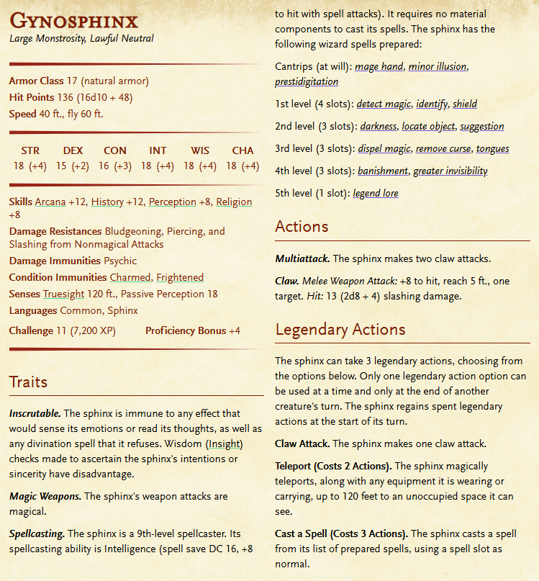

Room 2: Animated Flying Swords

A straightforward fight against a trio of animated swords. Orianna was not trying to kill her beloved family, so they will also deal nonlethal damage and will stop attacking any party member who they down.

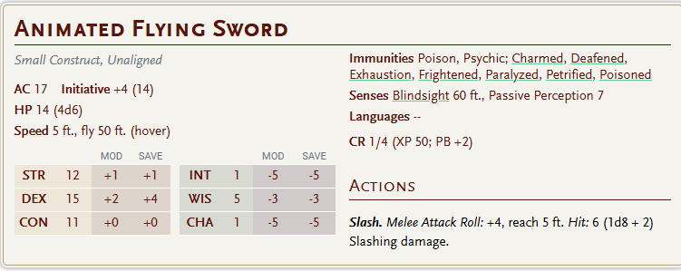
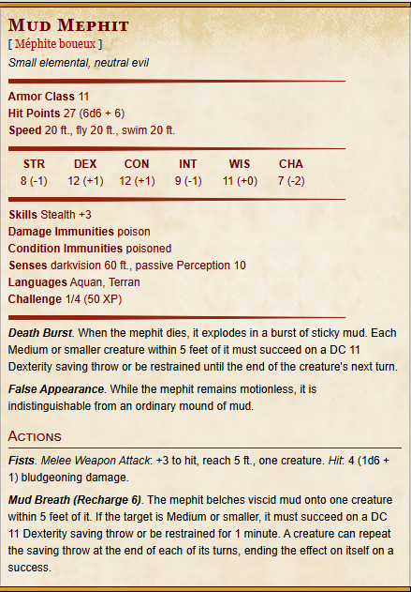

Room 3: Mud Mephits

These mud mephits will emerge from the muck of the room and hurl insults at the party on every one of their turns until they are defeated, at which point they merge back into the mud and remain dormant.

Room 4: Enclosing Walls

The walls will slowly start to close in on the party, giving them 2 rounds to stop it. This can be accomplished with a DC 15 Perception check to locate a hidden switch, or a DC 15 Athletics check to jam the walls and prevent them from moving. As before, Orianna was not trying to kill her family, so if the party does not figure it out in 2 rounds, the walls will stop short of crushing them and instead the floors will drop, sending the party on a slip and slide back to the start of the labyrinth.

Room 5: Quicksand

A hallway filled with quicksand. Can be navigated by a number of means: using the rope found in adventurers’ packs, magical shenanigans of the party’s design, setting up weight dispersal mechanisms built from old crates found in the nearby hallway, any other creative solution.

Room 6: Nothing!

Room 7: Instruments + Sphinx

Upon entering this room, the party will see a set of five instruments on pedestals: a violin, a bassoon, a reedpipe, an accordion, and a euphonium (instrument that resembles a mini-tuba). The first part of this room’s puzzle can be solved by playing the instruments in the order that spells out BRAVE with the first letter of each instrument - Bassoon - Reedpipe - Accordion - Violin - Euphonium. If the party isn’t catching on to the anagram puzzle, you can have them find the name of each instrument engraved below the pedestals where they sit, with the first letter carved much more ornately than the rest. If they still aren’t catching on, you can have Jaina suggest that perhaps they need to be played in a certain order; then have pedestals light up when the correct one is played in sequence.

Once the players finish this step, the sphinx will teleport into the room and pose a question to the assembled group: how do you define bravery? As long as the party gives an honest answer with a bit of thought, the sphinx will be satisfied, revealing Jaina’s corresponding line of the will and teleporting the entire party back upstairs into the armory room.

Finishing the Story

Once the party has revealed all five lines of the will, the family will request that everyone gather back in the dining hall and discuss how to interpret Countess Oriana’s wishes. As discussed in the How to Win section, there is no right or wrong answer here! At DM discretion - and depending on how the party’s encounters went with each family member - you could have certain members express wishes one way or another, either to be considered or NOT to be considered as a candidate. Ultimately they entrust the decision to the party as neutral arbiters - and problem-solvers who helped each of them have meaningful experiences utilizing the late countess’ gifts.

Maps

(see separate attachments)

Mansion (1F): 44x44 (can modify to 40x32 with reduced borders)

Mansion (2F): 44x44 (can modify to 40x32 with reduced borders)

Lake: 60x50

Town: 50x41

Labyrinth: 48x48

Chessboard: 8x8

